**ZnO:**

**Crystal Structure of ZnO:**

Wurtzite is the thermodynamically stable phase of the semiconductor compound ZnO at ambient temperatures. As shown in Figure 2.6, ZnO has a hexagonal unit cell and the determined lattice parameters of a = b = 3.2495 ( 0.00002) and c = 5.2069 ( 0.0001). It also belongs to the space group P63mc.The lattice parameters "a" and "c" in the wurtzite structure have a ratio of c/a=1.66 and make up each hexagonal unit cell.The structure is made up of two interlocking hexagonal-close-packed (hcp) sub lattices, each of which has one type of atom that is moved away from the other along the three fold c-axis by a distance of u=3/8=0.375 (in the ideal wurtzite structure) in fractional coordinates. The u parameter is defined as the length of the bond that runs parallel to the c axis, in units of c. The four atoms in each unit cell of each sub lattice are coordinated at the corners of a tetrahedron, and every atom of one kind (group-II atom) is surrounded by four atoms of the other kind (group-VI), or vice versa. These tetrahedrons typically feature sp3 covalent bonds, but they also have strong ionic characteristics that tend to make the band gap larger than would be predicted from covalent bonding. The wurtzite structure of actual ZnO crystals deviates from the ideal configuration by altering the c/a ratio. The structure is made up of AaBbAaBb... bi-atomic (0001) planes that alternate with one another [50].



**Figure 2.6:** Illustration of wurtzite ZnO in its hexagonal unit cell (a) and more atoms added to illustrate the alternating biatomic planes (b). The cell parameters are a = b = 3.2495 Å and c = 5.2069 Å. Figure (b) was created using the VESTA software [51].

The positive z direction for the crystal is the [0001] axis which points from the face of the oxygen plane to the zinc plane. Bonds along the c direction going from an zinc cation to an oxygen anion has a Zn polarity, and the opposite is true for bonding from oxygen to zinc and the two sides of the crystal is called Zn-face [0001] and O-face [000¯1].

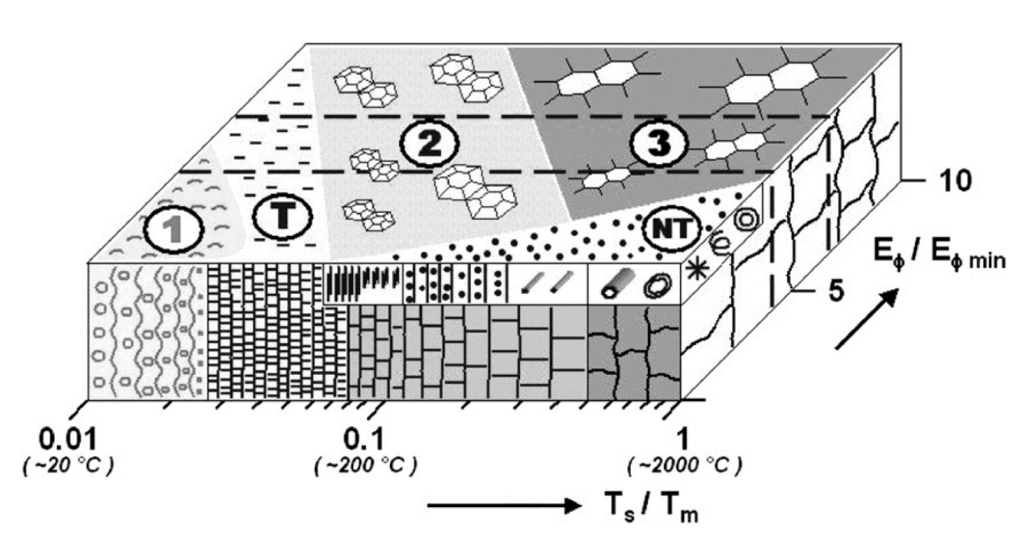

**Fig :** Crystalline structure zone model of sputtered ZnO thin films [52]

In the above picture, three types of zones are observed. All zones have distinct crystal orientations and characteristics.

**Zone 1:** This is a porous structure having tapered amorphous or crystalline nanograins separated by voids.

**Zone T:** This is a dense polycrystalline structure having fibrous and nanocrystalline grains.

**Zone 2:** This is a columnar grain structure.

**Zone 3:** This is a single-crystal micro-grain structure.

**Zone NT:** This is a zone of nanostructures and nanoelements.

**Defects in ZnO:**

In applications that take advantage of the diverse range of doped ZnO's capabilities, the control of imperfections and related charge carriers is of utmost importance. Solid surfaces, however, have distinct impurities, adsorbed gases that serve as electron sources and sinks, and connected space charge regions. Small length scales and a high surface-to-volume ratio in nanostructured ZnO (and other materials) lead to a larger influence of surface imperfections on characteristics. Understanding the flaws in ZnO that have been intentionally doped with aliovalent ions to achieve a certain functionality or accidentally doped during the growing process is equally crucial. Numerous intrinsic flaws with various ionization energies exist. i stands for the interstitial site, Zn for zinc, O for oxygen, and V for vacancy in the Kröger Vink notation. The terms denote the atomic sites, and the superscripted terms denote the charges. The charges are proportional to the number of symbols, with a dot denoting a positive charge, a prime denoting a negative charge, and a cross denoting zero charge. The bandgap of ZnO contains a variety of defect states, as shown in Fig. 2.7. The acceptor defects are VZn'', VZn', and the donor defects are Zni ••, Zni•, Zni*, VO ••, VO •, and VO [53].



**Figure 2.7:** Energy levels of native defects in ZnO. Reproduced from ref. [53].

The energies of defect ionization range from 0.05 to 2.8 eV. The most common ionic defect types are known to be oxygen vacancies and Zn interstitials. It is still up for debate as to which fault predominates in native, undoped ZnO.

**n-type ZnO:**

Since wurtzite-structured ZnO deviates from stoichiometry due to the presence of intrinsic defects such O vacancies and Zn interstitials, it is by nature an n-type semiconductor. With extremely high electron densities of about 1021 cm3.400, undoped ZnO exhibits intrinsic n-type conductivity. Although it has been demonstrated in experiments that accidentally doped ZnO is of the n type, it is still debatable as to whether Zni and VO are the donors. Group-III elements Al, Ga, and In can be employed as n-type dopants in ZnO to execute n-type substitutions for Zn as well as group-VII elements Cl and I to accomplish n-type substitutions for O [54]. Numerous teams have experimented with doping with Al, Ga, and In, producing excellent, highly conductive n-type ZnO films as a result. Such films are successfully used in a variety of applications, including transparent Ohmic connections and n-type layers in light-emitting diodes.